NEW MEXICO
SCHOOL OF MINISTRY PLUS
(NMSOM +)
2015-2016
ACADEMIC CATALOG
AND
POLICY MANUAL

New Mexico Ministry Network
of the
Assemblies of God

6640 Caminito Coors NW
Albuquerque, NM 87120
505-899-5399
www.nmministry.net

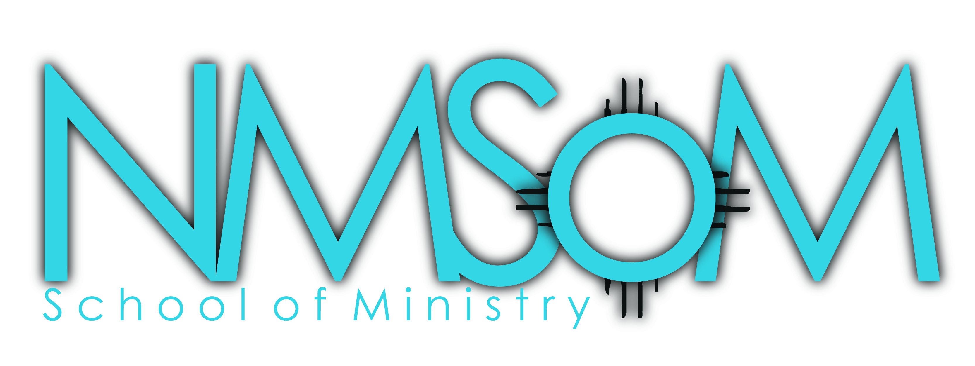

Dear Student ,

Welcome to the New Mexico School of Ministry Plus. We are glad to have you as a student in this new ministry of our Network.

God has placed a call upon your life to serve Him in ministry.

Your calling may be as a full-time minister and pastor or as an equipped layperson. We are here as a Network and as a school to help you process the call of God upon your life and prepare yourself to fulfill that call. NMSOM Plus is a selective leadership development track for ministers seeking to elevate their leadership skills.

NMSOM Plus instructors will invest in your life out of their experiences and knowledge. Classes are designed to be interactive in order to engage and stimulate your retention. I trust that you will find not only a friendly environment, but a class that gives you practical and useful knowledge that will enable your ministry to expand and be fruitful.

Thanks for joining the journey!

In Service to Christ, Our Lord,

Marcus W. McClain
Director of NMSOM & NMSOM Plus
505-899-5399
mmcclain@nmministry.net

PHILOSOPHY

Equipping the Called for 21st Century Ministry

What is New Mexico School of Ministry Plus (NMSOM +)?
- NMSOM Plus is a network sponsored and operated program targeted for those in ministry who would like to build upon their current foundation of knowledge and leadership.
- NMSOM Plus is a selective leadership development track for ministers seeking to elevate their leadership
- NMSOM seeks to provide the student with the highest quality instruction and resources possible in a practical and cost effective way.
- NMSOM Plus gives educational direction, sets an atmosphere for the impartation of the Spirit, and guides the student’s spiritual development to equip them for effective ministry.

What are the Benefits of NMSOM +?
- Establishes spiritual formation
- Builds lasting relationships
- Time measured and cost affordable
- Practical in structure
- Flexible and expandable in format
- Certificate awarded upon completion of the track.

Guiding Principles
NMSOM Plus is a unique ministerial training opportunity operating in the Network and is guided by the following principles:
- NMSOM Plus is not a college or university. Individuals who are able to attend college or seminary are strongly encouraged to attend an endorsed A/G college or seminary for the absolute best in ministerial training (www.colleges.ag.org).
- NMSOM Plus is not an accredited school. Students must not expect that the NMSOM courses will be accepted by any A/G college, Bible School, or other accredited college.
- NMSOM Plus is not the same a Berean or Global University correspondence education. Berean offers students correspondence courses that can be taken at any time and at the student’s own pace (www.thenewberean com). NMSOM Plus courses are only available at specific times.
- NMSOM Plus does not fulfill the credentialing requirements for the Assemblies of God. NMSOM Plus is an additional learning tool to build leadership skills for those in ministry or those seeking to go into ministry. Credentialing within our Fellowship is an altogether different process, with its own courses, exams, paperwork, and interview. Students interested in seeking credentials should contact the Network Executive Administrator’s office for additional information.
- NMSOM is for laypersons who may not be interested in full-time ministry but who want to learn and improve their ability to serve Christ and their church.
- NMSOM is for credentialed ministers who want to improve their skills and participate in an outstanding continuing education process.

STUDENT INFORMATION

Structure
Classes are conducted once a month, eight times a year, in a two-semester format. The classes take place on one Thursday of each month from 10 am to 2 pm, at the New Mexico Ministry Network office. NMSOM Plus will provide lunch at an offsite location

Prior to class, each student is required to read through the class textbooks(s), and complete any work assigned by the instructor.

Location
During the 2015-2016 academic year, all NMSOM Plus classes will be held at:

New Mexico Ministry Network
6640 Caminito Coors,
Albuquerque, NM 87120
Phone 505-899-5399

Textbooks

It is the responsibility of the NMSOM Plus student to find and purchase the required texts. A list of required readings and materials is contained in this manual along with their authors and ISBNs.

REGISTRATION

Enrollment
Those wishing to attend must register no less than three weeks prior to the start date of the class they wish to take. Registrations will be accepted in person at the New Mexico Ministry Network Office, by email, or by US mail only. Students may pay their class fee in person at the Network Office, at the NMSOM registration site, by mail, or on line at www.nmministry.net. If making payments on line, select the Giving tab and follow steps. Be sure to choose Network School of Ministry as the Purpose. There will be NO EXEPCEPTIONS TO REGISTRATION DEADLINES OR PAYMENT REQUIREMENTS.

Complete the registration and enrollment forms contained in this booklet and return them to the Network Office no less than three weeks prior to the class session.

PLEASE NOTE:
THE DEADLINE FOR REGISTRATION FOR A CLASS IS NO LESS THAN (3) THREE WEEKS PRIOR TO THE SESSION. YOU MUST REGISTER USING A REGISTRATION FORM IN PERSON AT THE NEW MEXICO MINISTRY NETWORK OFFICE, BY MAIL, OR EMAIL ONLY. EACH CLASS MUST BE PAID FOR BY THE CLASS DATE.

Fees

- Tuition is $50 per class, which includes an offsite lunch.
- Textbook costs will vary depending on the book and the supplier.
- Class fees are refundable if the refund conditions are met.
- Tuition is transferable to another class for up to 1 year.

Refunds

Refunds must be requested one week prior to the class in order to receive a full refund. Refunds requested after the deadline will be given on a case-by-case basis, for those who were unable to attend due to unforeseen circumstances. If the refund deadline cannot be met, the paid funds can also be credited towards the next available NMSOM Plus class. If you would like to receive a refund please email jstubbs@nmministry.net or call the network office at 505-899-5399.

Date | Class Name | Text | Author | IBSN
14-Jan-16 | Next Steps for Great Leaders | Good to Great | Jim Collins | 978-0066620992
11-Feb-16 | Tools for Leading to the Future Part 1 | Advanced Strategic Planning Part 1 | Aubrey Malphurs | 978-0801091810
10-Mar-16 | Tools for Leading to the Future Part 2 | Advanced Strategic Planning Part 2 | Aubrey Malphurs | 978-0801091810
21-Apr-16 | Leading From Vision to Action | The Four Disciplines of Execution | Chris McChesney | 978-1451627053
REQUIRED TEXTBOOKS
It is the responsibility of the NMSOM Plus student to find and purchase the required texts

